AGNISHEKHAR

MOTOR CODE LOGIC EXPLANATION

BELOW IS THE JOYSTICK PLANE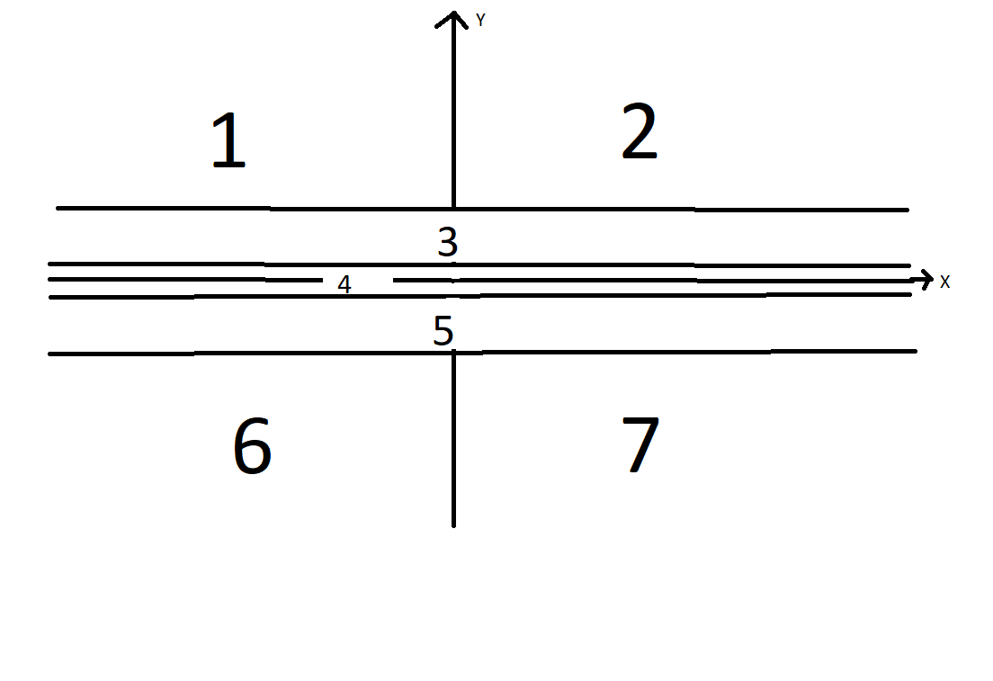

ZONES 3 AND 5 ON THE JOYSTICK PLANE ARE COMPLETELY DEAD AND DRIVE NO MOTOR.

ZONE 4 IS USED ONLY TO ZERO RADIUS TURN. IF THE JOYSTICK IS IN THAT ZONE THEN Y AXIS VALUES WITHIN THAT LIMIT MAP TO NOTHING. ONLY THE X AXIS VALUES MAP TO HOW FAST THE ZERO RADIUS TURN WILL BE AND IN WHAT DIRECTION.

REST IS EXPLAINED IN ALL OF THE PICTURES BELOW.

PLEASE WAIT FOR THE PICTURES TO LOAD IF U ARE OPENING IT IN THE PHONE. THEY ARE LARGE AND WILL OPEN SLOWLY.

HAVING A DEAD Y AXIS COMPONET ALSO HELPS IN HOT SWAPPING JOYSTICKS WITHOUT ANY CALIBRATION AT ALL. ALSO IT HELPS THE DRIVER BY BEING INSENSITIVE IN THAT REGION. IF IT WAS SLIGHTLY OFF THEN A MOTOR COULD BE ON WITH 2/256 DUTY CYCLE WHICH WOULD NOT MOVE THE ROVER AND WOULD ONLY WASTE POWER. THE OTHER MAIN FUNCTIONS OF THE ZONES ARE EXPLAINED BELOW.

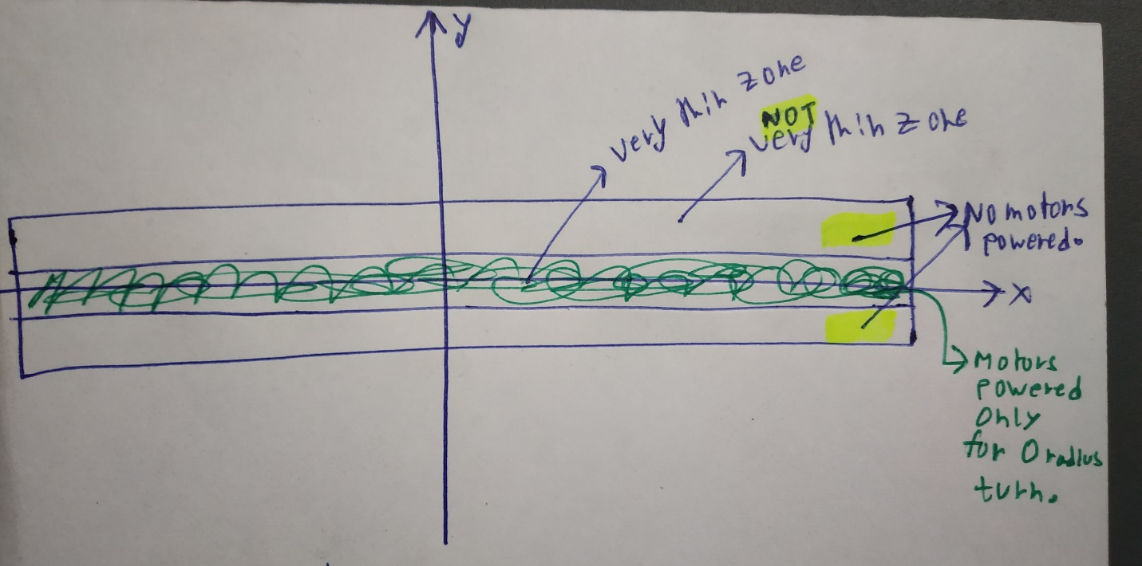

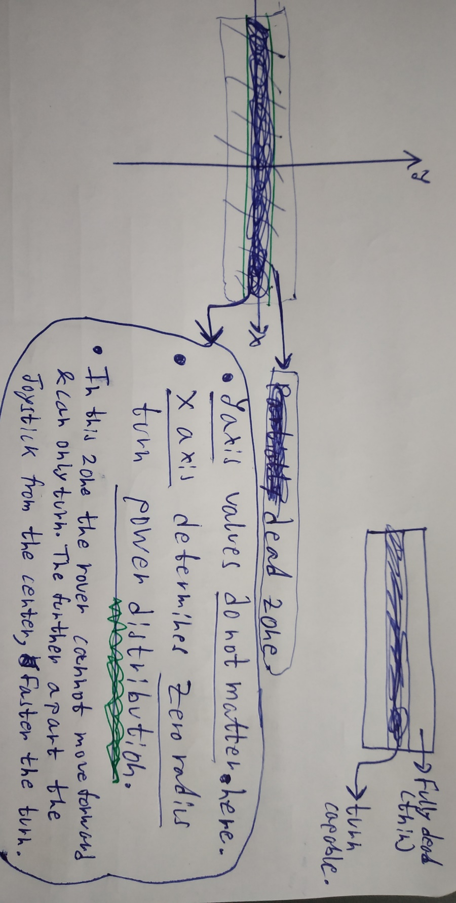

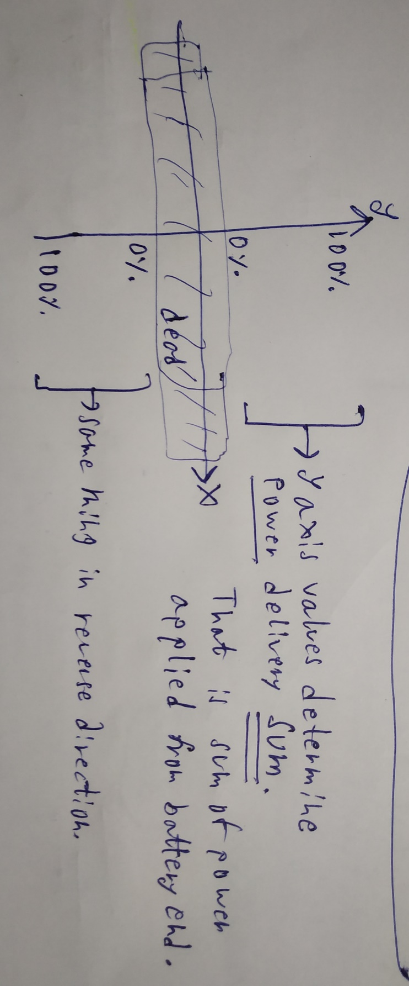

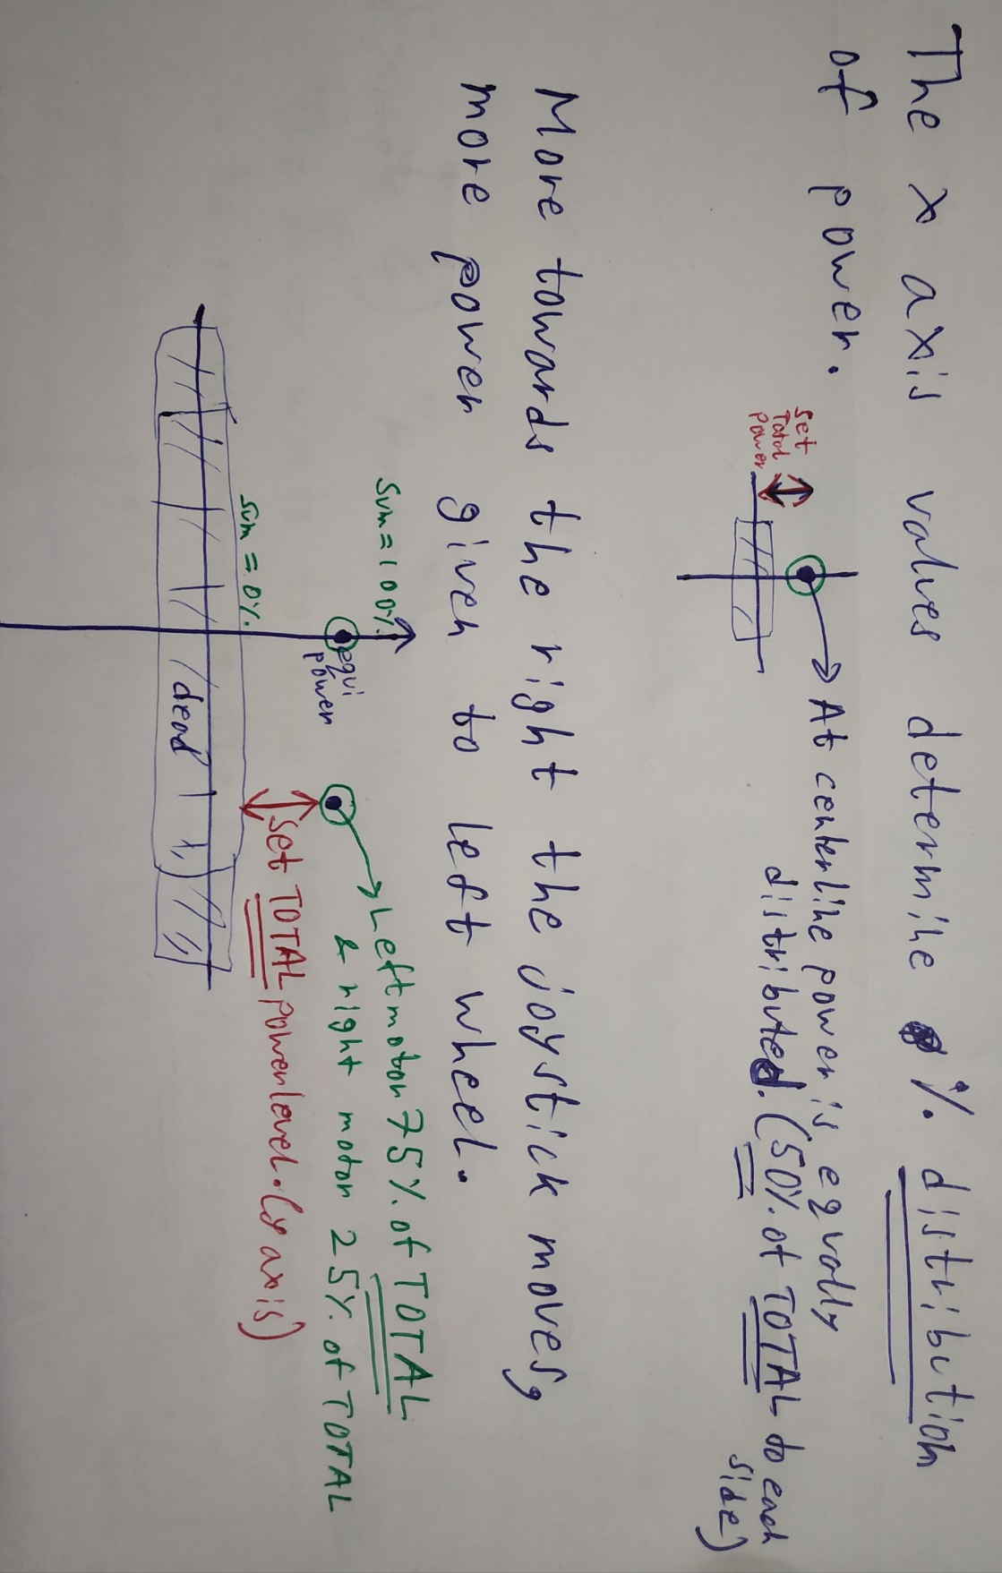



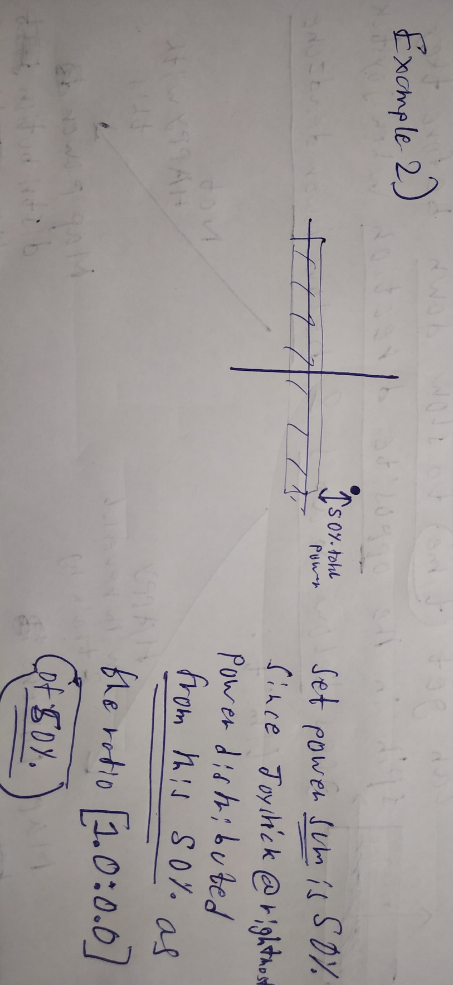

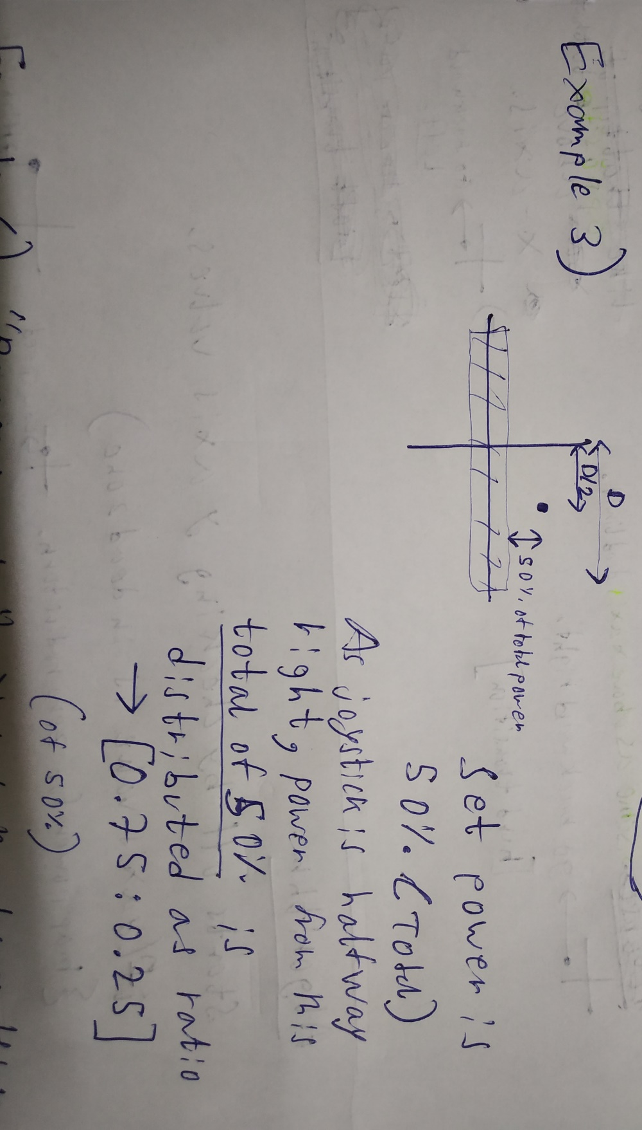



NOW TWO THINGS CAN BE DONE.

